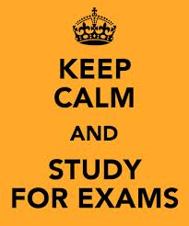

Extra Time in GCSE Music Listening Exams

These notes are to explain how extra time will work in your listening paper for GCSE Music.

The extra time will be allocated as follows:

After each of Questions 1 - 8: Extra 1 minute 30 seconds to complete answer.

At the end of the exam: Extra 10 minutes 30 seconds to complete and review answers.

If you have any questions about these arrangements, please come and talk to us in the Exams Office.

